Integrative Case Study

**Pure and Clean’s Expansion Overseas**

Sriram Kumar Reddy Challa - sxc190047@utdallas.edu

Venkata Narayana Ega - vxe180003@utdallas.edu

Jaswanth Pedapalli - jxp190002@utdallas.edu

Patty Phewklieng - ppp180003@utdallas.edu

Raelynn Robinson - rmr200000@utdallas.edu

*How can Pure and Clean enter foreign markets while maximizing profit and minimizing risk?*

Pure and Clean’s hypochlorous acid products are in high demand due to COVID-19. This case study examines different modes of entry for Pure and Clean to expand overseas into Turkey and Oman. The strategy that Pure and Clean chooses is dependent on its potential customers and how much commitment, costs, risk, and control it wants in the foreign market. The different export methods are discussed, and it is recommended that Pure and Clean take a small entry approach by using EX Works shipping which allows minimum risk and cost to Pure and Clean.

Roma Peace, the Vice President of Sales and Marketing for Pure and Clean LLC, is sitting at her desk and contemplating the company’s good fortune. While many companies are cutting costs and downsizing amidst the COVID-19 pandemic, Pure and Clean doubled their revenue in the month of March 2020 alone surpassing the entire year of 2019 due to the need to disinfect and sanitize. The demand for hypochlorous acid, a substance that kills SARS CoV-2 as well as many other viruses and bacterial particles, has surged worldwide. The company has expanded immensely to fulfill domestic demand, but as foreign demand increases no measures have been taken to address these desires.

The sharp increase in demand has forced the company to expand rapidly by bringing on more staff and moving into a larger facility. These new hires have had to face problems with distributors and hospital management but have never been faced with the task of exporting overseas. Pure and Clean up until the COVID-19 pandemic was implementing a growth strategy and was focused on expanding domestically. Once SARS CoV-2 spread throughout the world, VP Peace began receiving many inquiries from the Middle East, specifically from Turkey and Oman, asking if Pure and Clean could be shipped abroad. With no prior experience in entering a foreign market, Mrs. Peace wondered if it would be worthwhile to export to these destinations.

**Brief History of Pure and Clean**

Pure and Clean was founded in 2013 out of Nixa, Missouri, with the core mission to change global healthcare by providing disinfectant,sanitizer, and wound care products that are non-toxic. All Pure and Clean products are made up of varying strengths of hypochlorous acid (HOCl) which is 100x more effective than bleach as a disinfectant. HOCl is a new generation disinfectant used to clean, deodorize, and disinfect medical equipment and surfaces. HOCl is the most reactive oxygen species and leaves cellular dust behind meaning that bacteria cells are 100% eliminated rather than 99% or 99.9%. Products that eliminate 99.9% of bacteria allow the remaining 0.1% to become resistant and mutate giving rise to the ‘superbugs’ that are prevalent today. While HOCl is extremely effective in killing bacterial and viral particles our bodies are completely immune to HOCl making it safe to spray on the face and around the eyes.

**Customers**

Pure and Clean is a consumer-driven company that concentrates on a few vertical markets wherever the product's usage is high. Pure and Clean started out in the sports and school markets where young athletes could use a nontoxic product to sanitize equipment. Pure and Clean’s first major breakthroughs were the indoor football league and Olympic training center in Colorado Springs.

After a year in the sports and school industry, Pure and Clean started moving towards the medical industry focusing on wound care products. Roma Peace stated that “Pure and Clean products have been proven to accelerate the healing of chronic wounds.” Additionally, a research study on HOCl for wound management has confirmed that Pure and Clean products outperform other similar products in regards to healing. Pure and Clean’s HOCl wound cleanser provides patients with a solution to heal wounds while at the same time decreasing infection rates. Pure and Clean products are already available in Texas Health Resources Hospital System, Mayo Clinics, Baptist Health Systems, and wound clinics.

Pure and Clean products can also be used for treating various eye conditions, and the company has partnered with Vision Source to bring a safe and effective solution for eyelid, hand, and surface management. The hydrogel product is sold by Vision Source as a lid prep hydrogel and is used to treat a patient’s eyelids, eyelashes, and conjunctivitis to cleanse and manage the skin around the eyes. In addition, optometrists use the hand cleanser to prep their hands before treating a patient. These products are highly effective for use in optometrist offices, and this market is currently the most profitable.

The final and new vertical market for Pure and Clean is the COVID-19 market. The COVID-19 pandemic has changed the way people live resulting in a greater need for disinfecting products. The efforts to stay safe during the COVID-19 pandemic has greatly increased revenues for Pure and Clean. The pandemic led to the debut of a new product: the hand cleanser as well as increased the popularity of the surface cleanser. Quaternary ammonium compounds (quats) have been used in disinfectants for decades but high usage of those types of products has led to health problems in users. Widespread usage of disinfectants containing quats during the pandemic has put a spotlight on the hazards associated with these types of sanitizers, making environmentally safe products such as Pure and Clean more attractive.

**Competition**

Innovacyn, Inc is based in Rialto, California and is the closest competitor of Pure and Clean. Innovacyn, Inc is the parent company of Puracyn and Vetericyn which are wound and skincare products for the medical industry and animal health market respectively. Puracyn Plus contains HOCl which is safe and causes no harm to the skin or environment. Innovacyn, Inc developed partnerships in both North American and international markets. However, Vetericyn has a more global presence compared to Puracyn. Vetericyn expands its international presence by attending Interzoo, the largest pet supply trade show, for an opportunity to partner with new distributors worldwide.

The Clorox Company is a well-known global company that can be seen in almost every region of the world. It’s most popular products are its bleach and disinfecting products that help kill germs that make people sick. Clorox has played an important role during the COVID-19 pandemic by providing essential products such as disinfecting wipes and bleach.

Vashe Wound Solution is another prominent competitor of Pure and Clean. Vashe Wound Solution is intended for use in cleansing, irrigating, and moistening acute and chronic wounds. This solution of HOCl acts as a preservative that inhibits microbial contamination within the solution and mimics the normal pH of human skin. In addition, it is biocompatible, safe, and natural. Vashe Wound Solution is currently only sold in the USA and Canada, but the company has ambitions for international growth in the wound care market (see **Exhibit 1**).

**Country Analysis**

**Turkey**

Turkey lies partly in Asia and partly in Europe and is among the larger countries of the region in terms of territory and population. The Turkish economy experienced a decrease in growth in 2019 with an estimated average of 0.9% compared to 2.8% in 2018. Due to the outbreak of COVID-19, GDP growth is expected to fall to -5% in 2020 and pick up to 5% in 2021. The total value of exports and imports of goods and services equal to 60.4% of their GDP. Trade plays an important role in the economy, and the major import and export partners are Germany, Italy, the United States, France, and the United Kingdom. The Turkish people prefer to do business with people they know and respect so spending time establishing a personal relationship is crucial in business dealings.

**Oman**

Oman is located on the southeastern corner of the Arabian Peninsula, bordering the Arabian Sea and the Gulf of Oman. GDP growth is expected to fall to -2.8% in 2020 and pick up to 3% in 2021 subject to the post-pandemic global economic recovery. Oman exports mostly to China and India, and imports mostly from the United Arab Emirates, China, India, Japan, and the United States. The government is working to diversify the Omani economy due to the decline in oil prices by encouraging foreign investment and exploiting the country’s strategic location to create a hub for international shipping. Oman remains a deeply traditional and conservative country, so being respectful and observant of Islamic culture and traditions is important for business success. Upon meeting, formulaic greetings must be exchanged before a meeting can start, and business associates will want to spend more time finding out about you on a personal level.

**Potential Market**

**Market Size**

Turkey has a broad market for the schools and sports sector with 25.5 million students enrolled in the education institutions. Turkey’s hospital sector includes 1,534 hospitals which gives Pure and Clean a substantial healthcare market to penetrate. In total, there are 2 million people in Turkey and Oman afflicted by chronic wounds who could benefit from the accelerated wound healing properties offered in Pure and Clean products. Many consumers in Turkey and Oman engage in sanitizing practices with 64% of these combined populations using surface cleaners. Among these, 56% of people use bleach products to clean their surfaces and 46% use other products. Usage of HOCl is reportedly 30-35% in these Middle Eastern countries. HOCl is more expensive than bleach products, which could be a reason why its market share is considerably less than its bleach competitors. HOCl products in Turkey and Oman are more costly than in other countries which creates a potential opportunity for foreign firms to export HOCl and distribute at a lower price point (see **Exhibit 2**). Overall, the target market for HOCl in Turkey and Oman is approximately 20 million consumers for surface cleaners, 25.5 million school-aged children, and 2.1 million customers for wound management products.

**Market Growth**

The market for HOCl is gradually increasing as chronic wounds are becoming more prevalent. As of 2019, the global HOCl market size was USD 3.96 billion and is expected to reach USD 4.98 billion by 2026, with a compound annual growth rate (CAGR) of 3.3% during 2021-2026. Pre COVID-19 the industry maintained a relatively steady market growth, however, post outbreak, the market has seen enormous growth by exceeding all the previous year’s forecasts. Even though Turkey and Oman's GDP growth is forecasted to be negative for the upcoming year, the demand for HOCl is expected to grow exponentially.

**Export Methods**

Pure and Clean offers a number of health, personal care, and infection control products that do not jeopardize human or environmental safety for effectiveness. With its unique product reach, it can expand its base across different countries. Pure and Clean has different distribution strategy options to sell products overseas as seen in **Exhibit 3**. There are mainly two standard approaches to accomplish this which are direct and indirect exports. In addition, Ex Works (EXW) is another international trade option for Pure and Clean to expand overseas.

**Direct Exporting**

Direct exporting involves Pure and Clean selling goods directly to a customer in an international market. Direct exports would allow Pure and Clean to acquire knowledge on how trade is conducted overseas and also give them better control over distribution. Direct exporting is an entry strategy that might be suitable for organizations that want to expand their market share or maximize profits as direct exporting usually results in more sales compared to indirect exporting.

However, direct exporting has its own limitations like the high transportation cost for huge and bulky containers of sanitizers or cleansers. Pure and Clean must also assume responsibility for all losses during shipping and storage overseas. Substantial amounts of time must be invested in market contact, market research, physical distribution, and pricing. There is also a risk that these expenses will not be recouped if the venture is not successful. Political and economic instability in the market could also affect business growth.

**Indirect Exporting**

Indirect exporting involves Pure and Clean selling its products to an intermediary within the United States. This intermediary then sells the goods within the international market and takes on the responsibility of organizing paperwork and permits, shipping, and marketing activities. Indirect exporting is flexible, and exporting activities can cease immediately if required. Its greatest advantage is that intermediary organizations handle all the exporting activities. No exporting experience or skills are required as the intermediary organization takes on all the risks associated with shipping and organizing payment from the international market.

The main disadvantage is that the control of activities overseas transfers to the intermediary organization. If Pure and Clean is interested in expanding into a target market, it will not gain valuable knowledge about how that market functions. It is also impossible for Pure and Clean to establish after-sales service or value-added activities since there is no direct contact with the customer, and this can have an adverse effect on their reputation in a foreign country.

**Ex Works**

Ex Works (EXW) is an international trade term that describes when a seller makes a product available at a designated location, and the buyer of the product must assume responsibility for all further costs. Once buyers have their goods, they are responsible for all risks, such as loading the goods onto trucks, transferring them to a ship or plane, and meeting customs regulations. In this strategy, Pure and Clean is only required to safely package the goods, label them appropriately, and deliver them to a previously agreed-upon location, such as the seller's nearest port. EXW places the highest obligation and risk on the buyer since the buyer has to cover anything that is involved in the shipment process like damages or additional costs when clearing customs.

**Case Analysis**

Currently, Pure and Clean does not possess the necessary resources and capabilities to participate in direct exporting. A detailed VRIO framework and SWOT analysis can be seen in **Exhibit 4 and 5** to further explain the company’s competitive advantage as well as internal and external factors that positively and negatively affect the firm’s success. The company would need to invest a large sum of money in warehouses, trucks, delivery crew, and purchase an exporting license. Additionally, the company would be responsible for the incurred import taxes and duties. In Turkey, the import tax is currently 18%. For a pallet of disinfectant, which costs $12,481.50, the import tax would be $2,246. In Oman, there is currently a 0% import tax; however, there is a 5% duties tax. For the same shipment, the duties tax incurred by the Oman government would be $624. For Pure and Clean to successfully engage in direct exporting, it would be necessary for the company and, more specifically, the company’s representatives who would be going overseas to familiarize themselves with the country’s legal systems, business, and government regulations, and culture.

While indirect exporting gives the company less control over distribution, the company is relieved from dealing with protectionism costs. Hiring an intermediary to distribute products is less expensive than purchasing additional building storage space, hiring more employees, and paying for overseas shipping. However, intermediaries are still quite costly. The average intermediary charges a fee ranging between $750-$1,000 for each shipment. Indirect exporting limits the cost and shipping risks associated with directly exporting products. At the same time, it reduces the information a company can obtain from the foreign market.

EXW is the most inexpensive and risk-free option for Pure and Clean to ship products overseas. The buyer is responsible for the goods' price, sales taxes, shipping costs, and export license. Pure and Clean’s only cost would be transporting their products to their port of choice. Once the containers of Pure and Clean are picked up at the port by the buyer, the product is the buyer's responsibility. EXW shipping does not require the company to invest time in familiarizing themselves with a foreign market nor do they incur any additional expenses such as hiring an intermediary. All foreign buyers have contacted Pure and Clean first making this form of shipping the easiest and most cost-effective. As foreign demand grows, the company could reach a much larger customer base and profit more from other export methods.

**Recommendations**

We recommend that Pure and Clean initially enter Turkey and Oman's markets by taking a hands-off approach with EXW shipping. The company is currently in its growth stage and does not have the financial resources to spend a substantial sum of money exporting products overseas. A small scale of entry will be less costly and allow Pure and Clean to gauge the market success. EXW gives buyers more visibility by outlining the costs upfront and ensures supplier’s aren’t adding any extra cost to delivery. In addition, the buyer can control the entire shipping process to ensure their products are safe. Pure and Clean should obtain an export license to assist buyers on an easier export clearance as an added incentive for EXW shipping. As the company grows and transitions into its expansion stage, the pros associated with direct exporting may become more attractive. Some of the upsides of direct exporting include reaching foreign customers directly and the potential for sales abroad to offset downturns in the U.S. market. If Turkey and Oman prove to be large markets, direct exporting would help the company expand its market share overseas. After spending an initial investment on the costs associated with direct exporting, this non-equity entry mode would give the company pertinent knowledge on these foreign marketplaces.

Turkey and Oman abide by different legal systems and cultural norms than many Western counterparts, creating a liability of foreignness for Pure and Clean. To offset this liability of foreignness and minimize risk in these foreign markets, they must employ overwhelming resources and capabilities. Turkey practices civil law, and Oman practices a mix of theocratic law and Anglo-Saxon law. These legal systems vary tremendously from common law practiced in the United States. Pure and Clean must become accustomed to the following rules and traditions associated with these systems to develop their business in these countries properly. Understanding the different formal and informal rules of the game will reduce uncertainty and help them understand and adapt to these foreign markets.

Direct exporting requires careful planning, and often companies create a department devoted solely to exporting. It would be beneficial for Pure and Clean to hire an export team that can track sales in foreign markets while other employees focus on the domestic market. Direct exporting gives Pure and Clean the opportunity to create marketing content tailored to the Middle East and increase general awareness within these countries. This entry method potentially gives Pure and Clean the most financial reward but could also be very risky if their liability of foreignness is not offset.

**Conclusion**

There are a few different distribution strategies that have been considered for Pure and Clean to expand overseas to the Middle East. These non-equity modes reflect smaller commitments to the overseas market, and these different modes differ in terms of costs, commitment, risk, return, and control. However, a determination has been made to initially proceed with EXW shipping. EXW lets the buyer control the entire shipment process where cost and liabilities fall within the buyer allowing minimum responsibilities and cost to the seller. Both Turkey and Oman have a strong demand for Pure and Clean products making EXW the easiest and most cost-effective mode of entry. This approach will allow Pure and Clean to slowly enter the Middle Eastern market while limiting the risks associated with entering a foreign market. However, if the market proves to be successful, decisions to directly export can be reevaluated to include a greater market share in Turkey and Oman.

**References**

1. Ajay, More. (2020, August 10).*Global Hypochlorous Acid Market Size 2020 Industry Overview, Shares, Growing Demand, Explosive Factors of Revenue, Types, Applications and 2026 Forecast Report by Industry Research Biz.* (2020, August 10). WFMJ. <https://www.wfmj.com/story/42473833/global-hypochlorous-acid-market-size-2020-industry-overview-shares-growing-demand-explosive-factors-of-revenue-types-applications-and-2026-forecast>
2. Bugs Harpley. (2020). *Calculate Import Duties & Taxes to Turkey*. Easyship. [https://www.easyship.com/duties-and-taxes-calculator/turkey?value=12482&category=health_beauty¤cy=USD](https://www.easyship.com/duties-and-taxes-calculator/turkey?value=12482&category=health_beauty%C2%A4cy=USD)
3. Delaney, Laurel (2019, July 19). *Direct Exporting Advantages and Disadvantages.* The Balance Small Business. <https://www.thebalancesmb.com/direct-exporting-advantages-and-disadvantages-1953310>
4. Embassy, U. S. (2018, November 20). *Oman - Market Overview | export.gov*. Export.Gov. <https://www.export.gov/article?series=a0pt0000000PAucAAG&type=Country_Commercial__kav>
5. Gurtas, M. A. (2019, January 10). *Turkey: 1M+ health care professionals in 2018.* Anadolu Agency. <https://www.aa.com.tr/en/health/turkey-1m-health-care-professionals-in-2018/1598912>
6. *Oman.* Nations Online. Retrieved November 16, 2020, from <https://www.nationsonline.org/oneworld/oman.htm>
7. pure&clean™ products utilize the most profound HOCl solution available to positively impact healthcare medically and monetarily. <https://pureandclean.us/>
8. Roy, E. (2017, December 13). *Direct or indirect exporting: which is the best fit for your business?* Trade Ready. <http://www.tradeready.ca/2017/topics/market-entry-strategies/direct-indirect-exporting-best-fit-business/>
9. Sabah, D. (2018, September 18). *Number of students in Turkey surpasses population of 143 countries*. Daily Sabah. <https://www.dailysabah.com/education/2018/09/18/number-of-students-in-turkey-surpasses-population-of-143-countries>
10. *Turkey Corporate - Other taxes.* (2020, October 16). PWC. Retrieved November 18, 2020, from <https://taxsummaries.pwc.com/turkey/corporate/other-taxes>
11. *Turkey: Economic and Political Outline.* Santander Trade. Retrieved November 16, 2020, from <https://santandertrade.com/en/portal/analyse-markets/turkey/economic-political-outline>
12. *Turkey - Turkish Language, Culture, Customs, and Etiquette.* Commisceo Global. Retrieved November 16, 2020, from <https://www.commisceo-global.com/resources/country-guides/turkey-guide>

**Case Discussion Questions**

1. From a resource-based view, does Pure and Clean have the necessary resources and capabilities to participate in international trade?
2. If you were the CEO of Pure & Clean, would you support the idea of overseas expansion?
3. For Pure and Clean, how does the country-of-origin image affect Turkey and Oman's market?

**Exhibit 1: Pure and Clean Competitors**

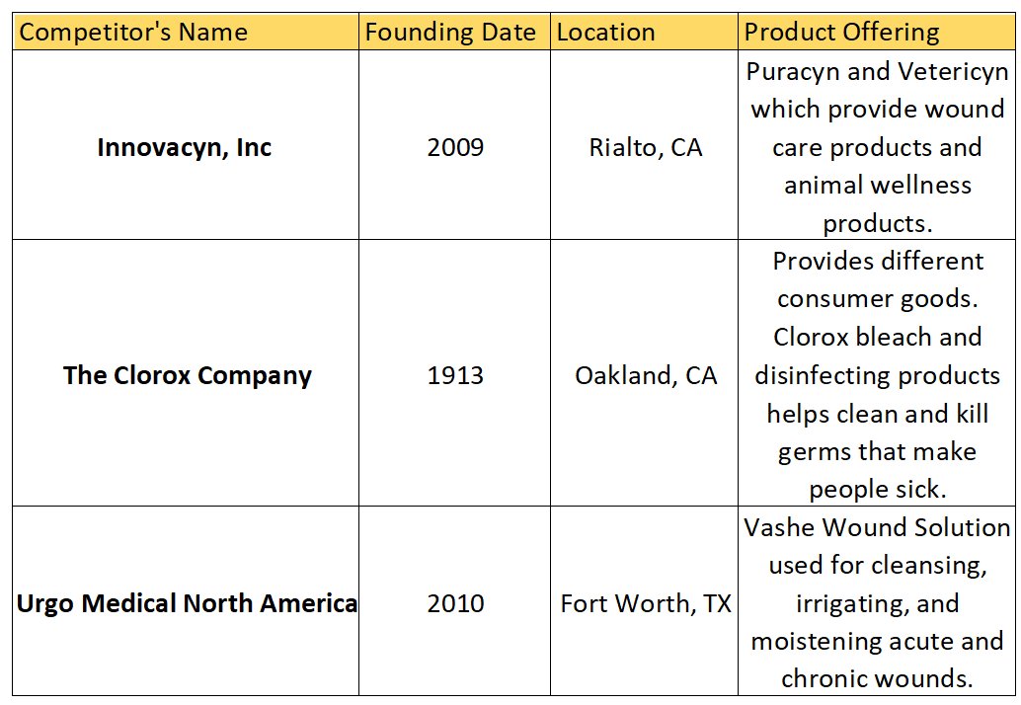

**Exhibit 2: Unit Margin for Pure and Clean in the overseas market**

|  |  |  |  |  |
| --- | --- | --- | --- | --- |
| **Quantity** | **Current price in Turkish Lira** | **New Price** | **US price** | **Margin from new foreign market** |
| 8 Oz First aid solution | 679 ($89) | 539 ($69.99) | $27.99 | $42 |
| 1 Gallon surface cleaner | 1299 ($169) | 809 ($104.99) | $41.99 | $63 |
| 2 Oz wound cleanser | 379 ($49.25) | 269($34.99) | $13.99 | $21 |
| 1 Gallon sanitizer | 1599 ($207.8) | 1155($149.99) | $59.99 | $90 |

**Exhibit 3: Distribution Strategies**

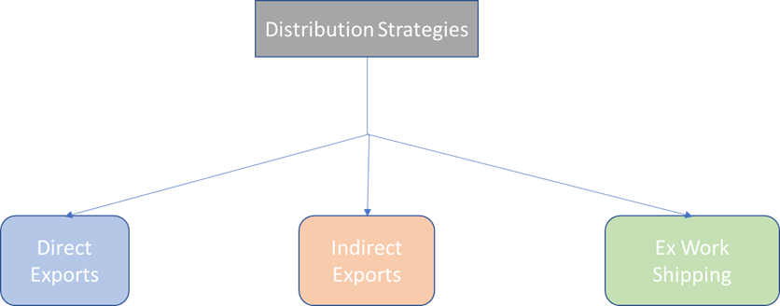

**Exhibit 4: VRIO Framework**

|  |  |
| --- | --- |
| Value   * HOCl is 100x more effective than bleach as a disinfectant. * Pure and Clean accelerates the healing of chronic wounds. | Rarity   * Pure and Clean products have a 24 month shelf life, significantly longer than competitor products. |
| Imitability   * Start up costs are high when establishing a company that produces disinfectants/sanitizers. * Receiving FDA approval on products can sometimes take up close to a year. | Organization   * More staff have been hired to fulfill order demands as quickly and efficiently as possible. * The company has increased manufacturing to better supply growing demand for HOCl products, resulting in a surge in revenue. |

**Exhibit 5: SWOT Analysis**

|  |  |
| --- | --- |
| Strengths   * P&C products accelerate wound healing * All products are non-toxic * HOCl kills 100% of bacteria rather than 99% or 99.9% | Weaknesses   * There are cheaper disinfectants in the market * Sudden demand for disinfectant products has put a strain on P&C manufacturers |
| Opportunities   * Increased domestic demand for HOCl generates more revenue for the company which can help facilitate their expansion overseas. * Growing foriegn demand gives P&C the incentive to penetrate new markets | Threats   * The U.S. government could restrict exportation of disinfectant products if COVID-19 cases continue to rise. |